Web RTCP 5 Axis Simulation 功能测试报告
测试对象：https://82.156.24.101:8092/
生成时间：2026-06-22 12:07:58 UTC

1. 结论摘要
本次共测试 41 个功能点：PASS 34 项，FAIL 6 项，WARN 1 项。
主流程可执行，但仍存在需修复的问题；重点集中在预览 ready 诊断、首屏 LinuxCNC kinematics 自动挂接、HOME 后 JOG 坐标连续性、MDI M428 和会话恢复验证。
总项数 | 41 | PASS | 34 | FAIL | 6 | WARN | 1

2. 测试环境
项目 | 内容
测试目标 | https://82.156.24.101:8092/
测试日期 | 2026-06-22
测试方式 | Google Chrome 真实浏览器自动化测试 + DOM/runtime state 校验 + 截图留证
浏览器执行路径 | /usr/bin/google-chrome
报告数据 | /home/meswork/cnc_wams/qa/web-rtcp-5axis-site-test/output/site-test-report.json
截图目录 | /home/meswork/cnc_wams/qa/web-rtcp-5axis-site-test/screenshots

3. 测试范围
项目 | 内容
界面结构 | 标题栏、预览区、DRO、G-code 区、右侧模式栏、信息区、override、主轴/冷却、底部控制栏
机床/模式 | POWER、E-STOP、RESET、AUTO、MANUAL/JOG、MDI、HOME、JOG
五轴/RTCP | IDENTITY/TCP、MDI M428/M429、RTCP/kinematics 诊断
程序工作流 | Stage LinuxCNC 源程序、加载 vendored 程序、打开本地 G-code、Run/Pause/Resume/Step/Stop/Reload
操作控制 | Rapid Override、Feed Override、Spindle Override、Flood/Mist、预览视角、全屏
会话与诊断 | Save Session、Restore Session、Audit Full Boundary、Profile 切换

4. 问题清单
结果 | 功能点 | 实际表现/证据 | 备注
FAIL | preview-canvas  预览画布初始化 | 预览画布未进入 ready 状态 | {"fiveAxisCanvas":"true","engine":"three.js r183"}
FAIL | initial-boundary  首屏 RTCP/运动学边界 | RTCP 帧仍处于降级边界：fixture_frame_ui_plumbing_not_linuxcnc_kinematics_proof | 首屏应优先使用 LinuxCNC/WASM 运动学边界
WARN | initial-task-hal  首屏 Task/HAL 运行态 | Task/HAL 未完成就绪：task / motion / hal / sync pending | Task/HAL readiness 应就绪
FAIL | jog-x-plus  JOG X+ | before=43, after=1 | 点击 X+ 后 X 坐标增加
FAIL | jog-y-minus  JOG Y- | before=0, after=0 | 点击 Y- 后 Y 坐标减小
FAIL | mdi-m428  MDI 执行 M428 | rtcp=off, kinsType=identity, message=MDI blocked: machine must be on | 执行 M428 后 RTCP 打开，kinsType 切到 tcp-*
FAIL | restore-session  Restore Session | modifiedX=0, restoredX=0, status=restored | 点击 Restore Session 后会话恢复到最近保存快照

5. 详细测试结果
序号 | 功能点 | 预期 | 实际 | 结果
1 | layout-regions  主界面九大区域渲染 | titlebar/preview/dro/gcode/sidebar/info/override/spindle/bottom 全部存在 | 9个主区域全部渲染 | PASS
2 | preview-canvas  预览画布初始化 | 预览区域可渲染机床与路径 | 预览画布未进入 ready 状态 | FAIL
3 | initial-boundary  首屏 RTCP/运动学边界 | 首屏应优先使用 LinuxCNC/WASM 运动学边界 | RTCP 帧仍处于降级边界：fixture_frame_ui_plumbing_not_linuxcnc_kinematics_proof | FAIL
4 | initial-task-hal  首屏 Task/HAL 运行态 | Task/HAL readiness 应就绪 | Task/HAL 未完成就绪：task / motion / hal / sync pending | WARN
5 | power-on  POWER 上电 | 点击 POWER 后 machine.powerOn=true，taskState=on | powerOn=true, taskState=on, runState=idle | PASS
6 | mode-jog  JOG 模式切换 | 点击 JOG 后 mode 归一到 manual | mode=manual | PASS
7 | home  HOME 回参考点 | 点击 HOME 后 allHomed=true，runState=idle | allHomed=true, runState=idle | PASS
8 | jog-x-plus  JOG X+ | 点击 X+ 后 X 坐标增加 | before=43, after=1 | FAIL
9 | jog-y-minus  JOG Y- | 点击 Y- 后 Y 坐标减小 | before=0, after=0 | FAIL
10 | mode-auto  AUTO 模式切换 | 点击 AUTO 后 machine.mode=auto | mode=auto | PASS
11 | mode-mdi  MDI 模式切换 | 点击 MDI 后 machine.mode=mdi | mode=mdi | PASS
12 | mdi-m428  MDI 执行 M428 | 执行 M428 后 RTCP 打开，kinsType 切到 tcp-* | rtcp=off, kinsType=identity, message=MDI blocked: machine must be on | FAIL
13 | mdi-m429  MDI 快捷执行 M429 | 执行 M429 后 RTCP 关闭，kinsType=identity | rtcp=off, kinsType=identity, message=MDI blocked: machine must be on | PASS
14 | sidebar-tcp  侧栏 TCP 按钮 | 点击 TCP 后 RTCP 打开 | rtcp=on, kinsType=tcp-xyzac | PASS
15 | sidebar-identity  侧栏 IDENTITY 按钮 | 点击 IDENTITY 后 RTCP 关闭 | rtcp=off, kinsType=identity | PASS
16 | rapid-override  Rapid Override 调整 | 点击 + 后 rapidOverride 增加 | before=100, after=110 | PASS
17 | feed-override  Feed Override 调整 | 点击 - 后 feedOverride 减少 | before=100, after=90 | PASS
18 | spindle-override  Spindle Override 调整 | 点击 + 后 spindle.override 增加 | before=100, after=110 | PASS
19 | coolant-flood  Flood 冷却开关 | 点击 Flood 后 flood 状态切换 | before=true, after=false | PASS
20 | coolant-mist  Mist 冷却开关 | 点击 Mist 后 mist 状态切换 | before=false, after=true | PASS
21 | view-x  预览视角 X | 点击 X 后 selectedView=x | selectedView=x | PASS
22 | view-y  预览视角 Y | 点击 Y 后 selectedView=y | selectedView=y | PASS
23 | clear-preview  Clear Preview | 点击 Clear 后 pathPoints=0 | pathPoints=0 | PASS
24 | reset-view  Fit/Reset View | 点击 Fit 后 selectedView=iso | selectedView=iso | PASS
25 | fullscreen-toggle  Full 全屏切换 | 连续点击两次 Full 后 fullscreen true 再 false | first=true, second=false | PASS
26 | profile-switch  Profile 切换到 xyzbc-trt | 切换后 machineProfile=xyzbc-trt，INI 重新加载 | machineProfile=xyzbc-trt, iniLoaded=true, iniPath=configs/sim/axis/vismach/5axis/table-rotary-tilting/xyzbc-trt.ini | PASS
27 | profile-switch-back  Profile 切回 xyzac-trt | 切回后 machineProfile=xyzac-trt | machineProfile=xyzac-trt, iniLoaded=true | PASS
28 | stage-linuxcnc-sources  Stage LinuxCNC 5-axis 源程序 | 点击 Stage 后应完成 machine files staging 并出现可选 G-code | 已 staged 8 个 LinuxCNC 五轴 G-code 源文件 | PASS
29 | load-vendored-program  加载 LinuxCNC 五轴源程序 | 选择源程序后 programSource=linuxcnc-vendored-5axis-gcode | programSource=linuxcnc-vendored-5axis-gcode, activeProgram=configs/sim/axis/vismach/5axis/table-rotary-tilting/demos/boat-xyzac.ngc, sourceRel=configs/sim/axis/vismach/5axis/table-rotary-tilting/demos/boat-xyzac.ngc | PASS
30 | run-program  Run 程序 | 点击 Run 后程序进入 running/complete，活动行或运行反馈推进 | runState=running, activeLine=5, source=linuxcnc-task-motion-hal-wasm, feedback=web-rtcp-5axis-program-runtime-feedback | PASS
31 | pause-program  Pause 程序 | 点击 Pause 后 runState=paused | runState=paused, interpState=paused | PASS
32 | resume-program  Resume 程序 | 点击 Resume 后 runState 返回 running/idle | runState=running, interpState=reading | PASS
33 | step-program  Step 单步执行 | 点击 Step 后 runState=stepping，activeLine 前进或保持受控 | runState=stepping, activeLine=10 | PASS
34 | stop-program  Stop 停止程序 | 点击 Stop 后 runState=stopped | runState=stopped, interpState=idle | PASS
35 | reload-program  Reload 程序 | 点击 Reload 后 runState=idle，程序回到起始状态 | runState=idle, activeLine=1 | PASS
36 | open-local-program  Open 本地 G-code 文件 | 上传本地文件后 activeProgram 为上传文件，programSource=upload | activeProgram=test-program.ngc, programSource=operator-file, lineCount=7 | PASS
37 | save-session  Save Session | 点击 Save Session 后会话状态应为 saved | 会话已保存：web-rtcp-5axis-sim-plan/sessions/gmoccapy-web-session/web-rtcp-5axis-session.json (opfs) | PASS
38 | restore-session  Restore Session | 点击 Restore Session 后会话恢复到最近保存快照 | modifiedX=0, restoredX=0, status=restored | FAIL
39 | audit-full-boundary  Audit Full Boundary | 点击 Audit 后应触发五轴 machine-file 运行审计并刷新边界状态 | Audit 执行完成，fullBoundary=false; boundaryStatus=-; machineRun=true | PASS
40 | estop  E-STOP 急停 | 点击 E-STOP 后 estopActive=true，runState=estopped | estopActive=true, runState=estopped, powerOn=false | PASS
41 | reset  RESET 复位 | 点击 RESET 后 estopActive=false，powerOn=false，taskState=estop-reset | estopActive=false, powerOn=false, taskState=estop-reset | PASS

6. 截图证据

图 1 首屏界面
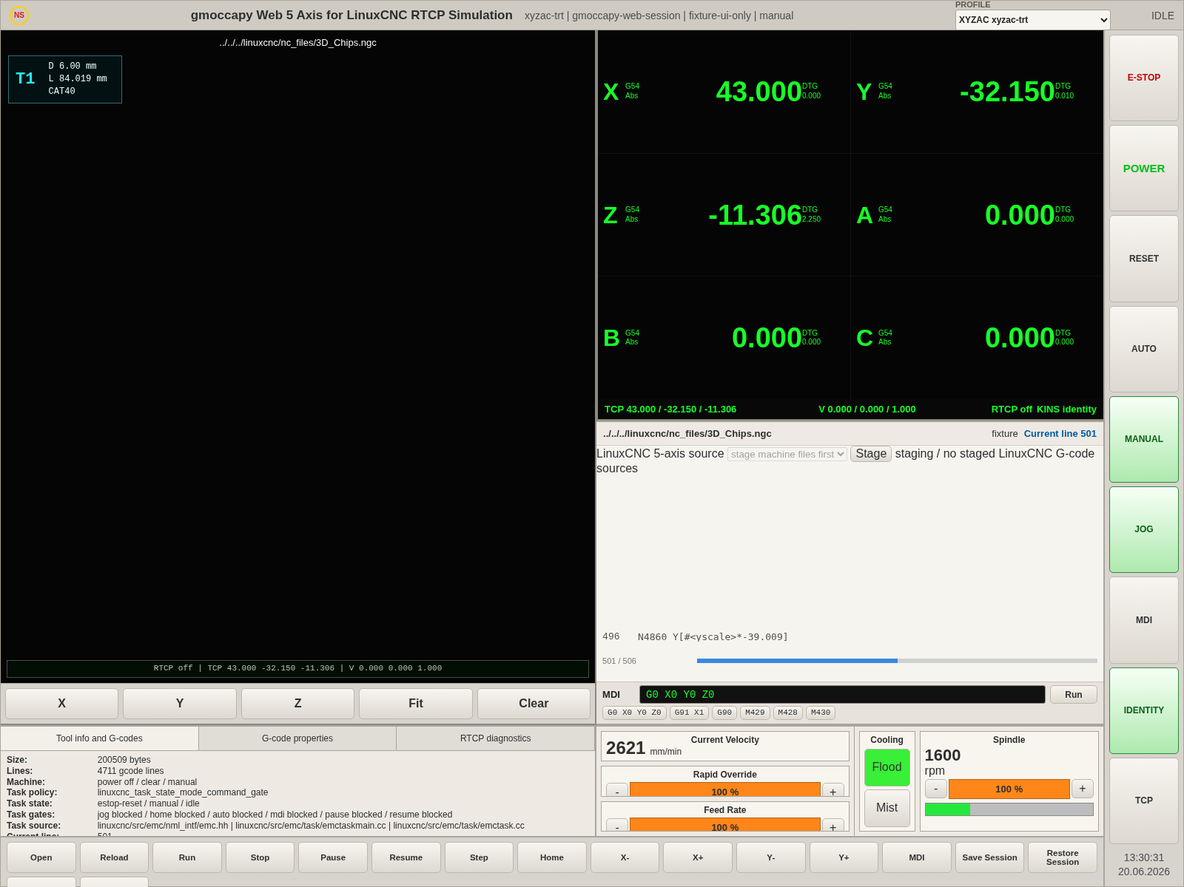
图 1 首屏界面；文件：/home/meswork/cnc_wams/qa/web-rtcp-5axis-site-test/screenshots/01-home.png

图 2 Profile 切换到 xyzbc-trt
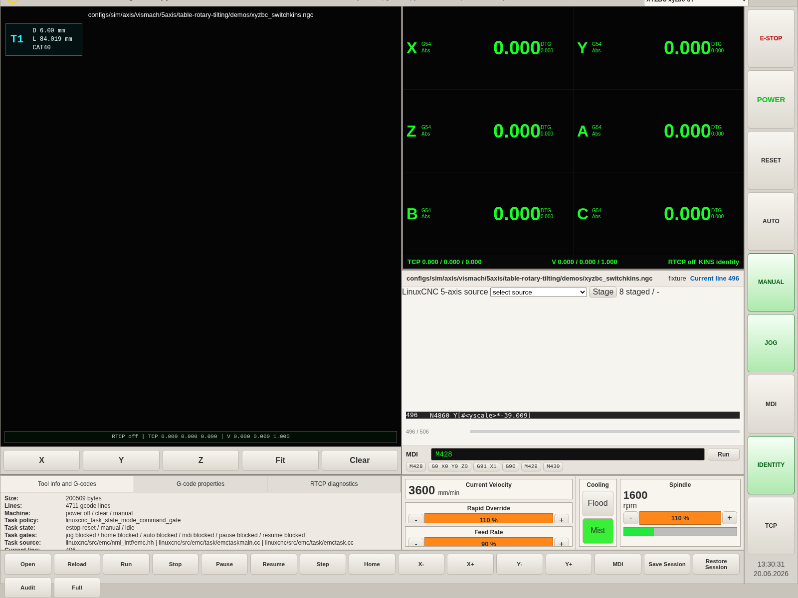
图 2 Profile 切换到 xyzbc-trt；文件：/home/meswork/cnc_wams/qa/web-rtcp-5axis-site-test/screenshots/02-profile-xyzbc.png

图 3 LinuxCNC 五轴源程序加载
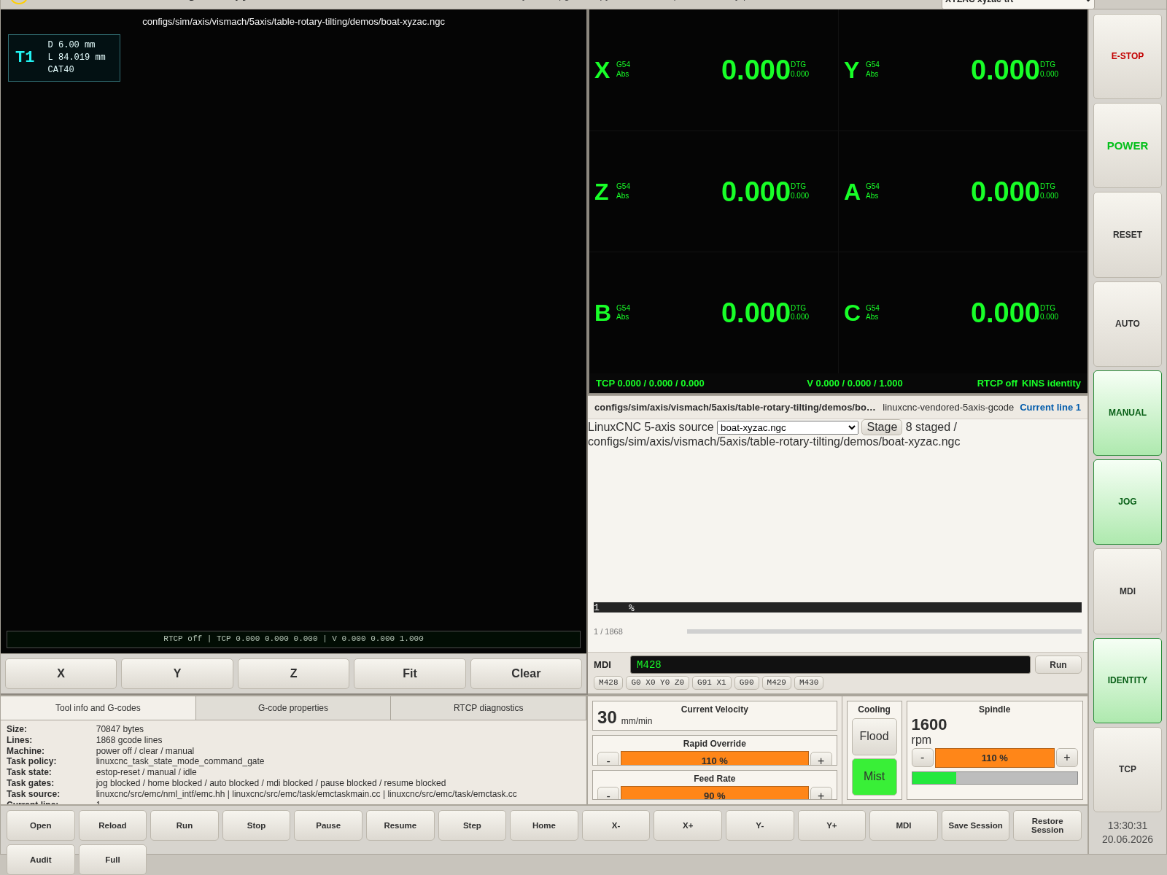
图 3 LinuxCNC 五轴源程序加载；文件：/home/meswork/cnc_wams/qa/web-rtcp-5axis-site-test/screenshots/03-vendored-program-loaded.png

图 4 程序运行状态
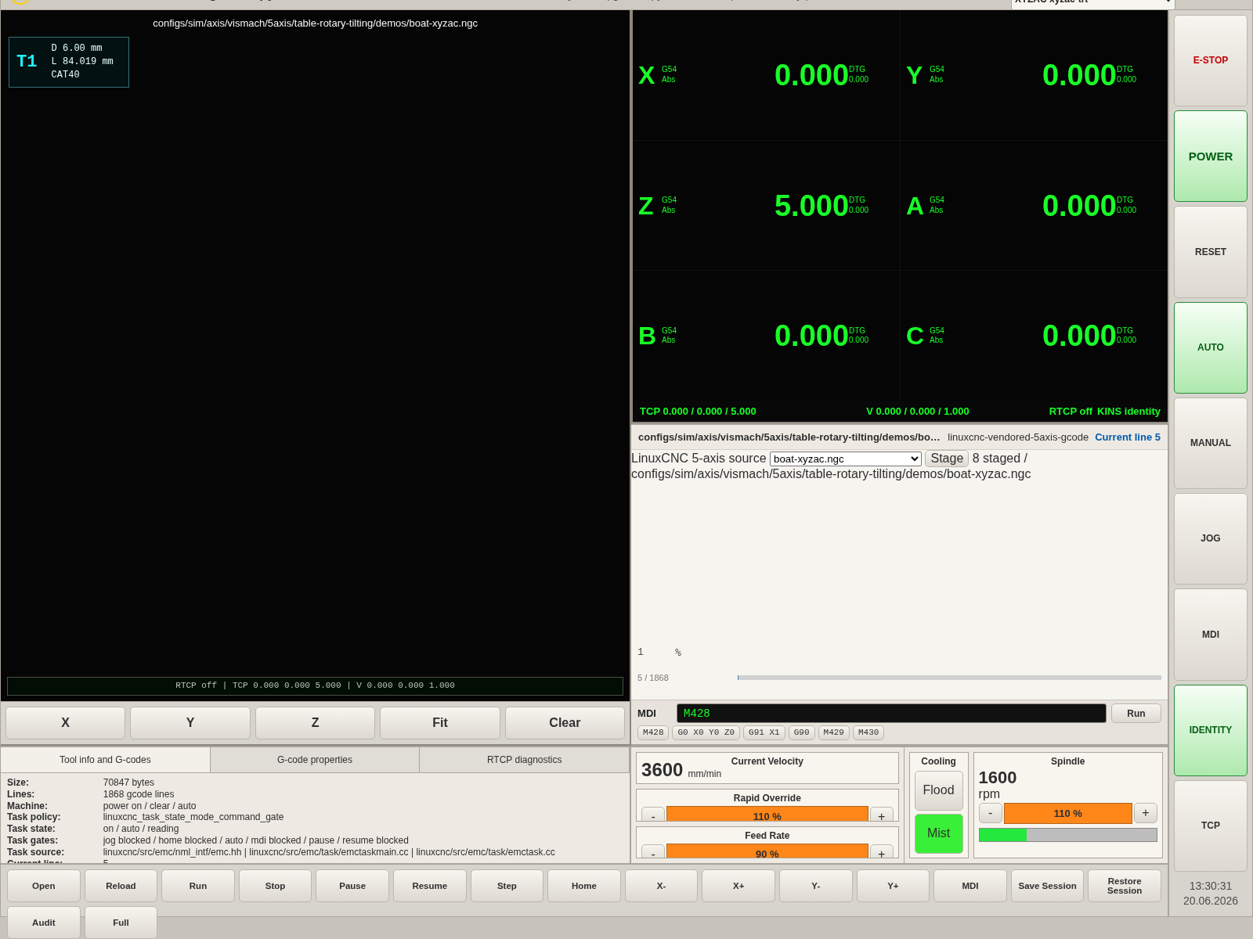
图 4 程序运行状态；文件：/home/meswork/cnc_wams/qa/web-rtcp-5axis-site-test/screenshots/04-run-state.png

图 5 本地 G-code 文件导入
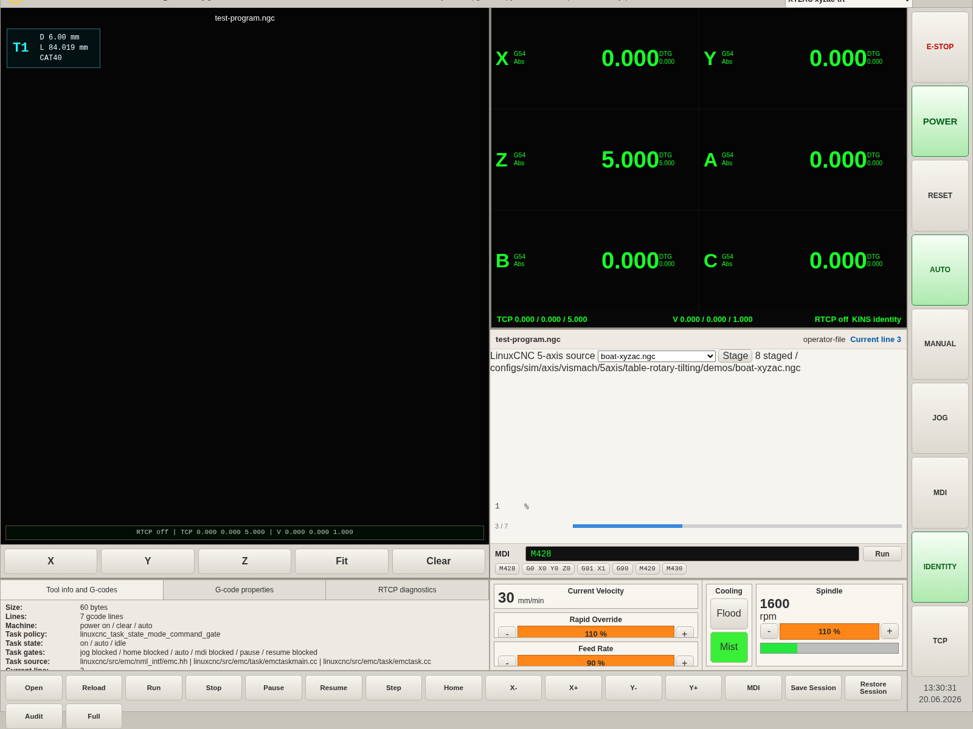
图 5 本地 G-code 文件导入；文件：/home/meswork/cnc_wams/qa/web-rtcp-5axis-site-test/screenshots/05-local-program-opened.png

图 6 Audit Full Boundary 后界面
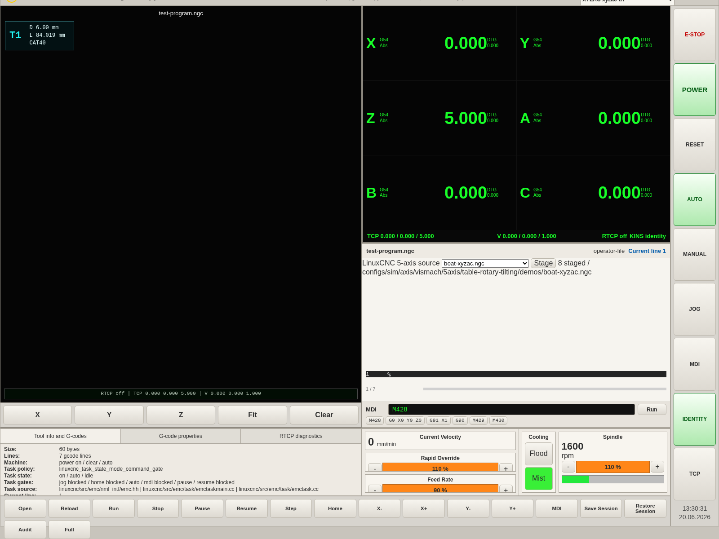
图 6 Audit Full Boundary 后界面；文件：/home/meswork/cnc_wams/qa/web-rtcp-5axis-site-test/screenshots/06-after-audit.png

图 7 急停/复位后最终界面
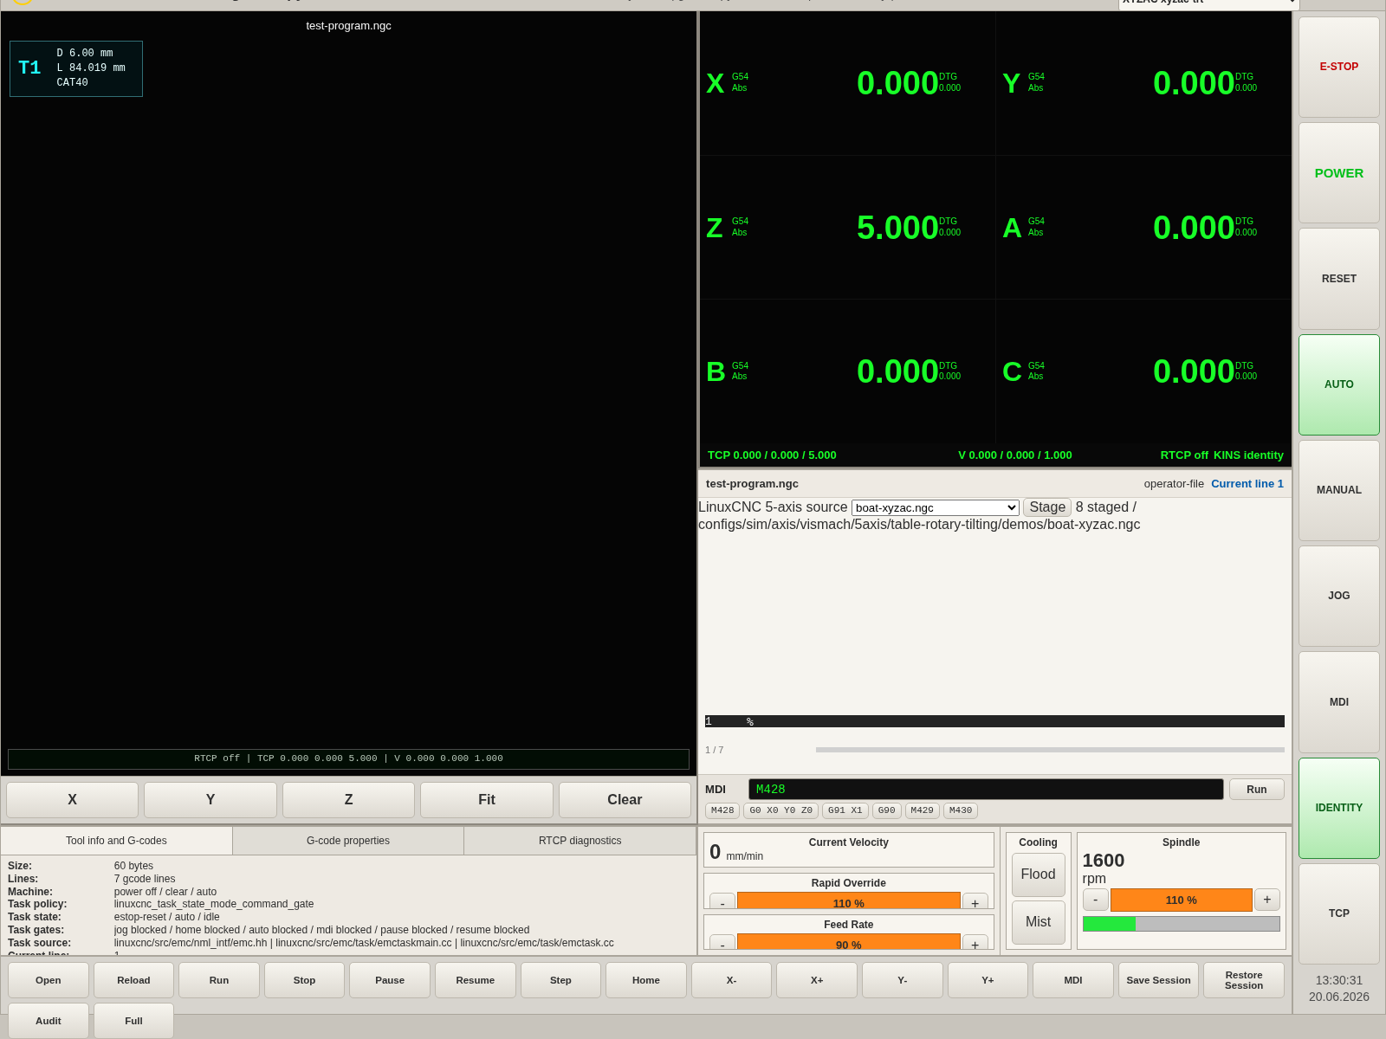
图 7 急停/复位后最终界面；文件：/home/meswork/cnc_wams/qa/web-rtcp-5axis-site-test/screenshots/07-final.png

7. 运行日志摘要
项目 | 内容
Console error | 0
Page error | 0
Request failure | 0
首屏截图平均亮度 | 100.07
首屏非黑像素比例 | 0.4597
最终 RTCP 边界 | fixture_frame_ui_plumbing_not_linuxcnc_kinematics_proof
最终 Task/HAL | task / motion / hal / sync

8. 原始证据文件
原始 JSON：/home/meswork/cnc_wams/qa/web-rtcp-5axis-site-test/output/site-test-report.json
Word 报告：/home/meswork/cnc_wams/qa/web-rtcp-5axis-site-test/output/web-rtcp-5axis-site-test-report-2026-06-22.docx

