刀具预览与 G-code 执行刀具轨迹专项测试报告
测试对象：http://127.0.0.1:43627/web-rtcp-5axis-sim-plan/app/index.html
项目路径：/home/meswork/cnc_wams/web-rtcp-5axis-sim-plan/app/index.html
生成时间：2026-06-22 13:12:11 UTC

1. 测试结论
本次专项覆盖 6 个刀具预览/刀具轨迹场景：PASS 6 项，FAIL 0 项。
已验证首屏预览、矩形 G-code、圆弧 G-code、清空预览、LinuxCNC vendored impeller 长路径、RTCP 运行态执行轨迹。截图中机床参考模型、TCP 球、刀轴线和刀路均有可见性证据。
发现 1 项关键问题：vendored impeller 程序在预览态为 RTCP on，但进入 G-code 运行态后 canvas dataset 中 RTCP 状态变为 off。
场景总数 | 6 | PASS | 6 | FAIL | 0

2. 测试范围与判定口径
项目 | 内容
预览对象 | 五轴机床参考模型、工作台、XYZ 坐标轴、旋转轴、刀具/TCP 球、刀轴线
轨迹对象 | G-code canonical motion 预览路径、rapid/feed/arc 分层、已执行轨迹、当前段高亮
运行反馈 | LinuxCNC interpreter WASM、TP/runtime samples、task/HAL runtime feedback
可见性口径 | canvas dataset ready + WebGL renderer + scene objects + pixel luminance/non-black ratio + 截图
语义边界 | 可视化层只消费 runtime/canonical motion/task-HAL feedback，不生成 G-code/CNC 语义

3. 场景结果总表
场景 | 结果 | 路径点 | 执行点 | RTCP | 可见性
01-home-toolpath  默认首屏预览：机床参考模型、TCP 球、刀轴线、fixture 路径和执行轨迹可见 | PASS | 2 | 1 | on | luma=62.52  nonBlack=0.7491
02-operator-demo-toolpath  本地矩形 G-code：验证 LinuxCNC interpreter canonical motion、rapid/feed 区分、执行轨迹和 TCP 标记 | PASS | 6 | 1 | on | luma=59.4  nonBlack=0.7092
03-arc-demo-toolpath  圆弧 G-code：验证 ARC_FEED 进入弧线轨迹图层并保留执行轨迹 | PASS | 2 | 1 | on | luma=65.26  nonBlack=0.7885
04-clear-preview-reference  清空刀路后：路径点为 0，但机床参考模型、TCP 球和刀轴线仍应可见 | PASS | 0 | 0 | on | luma=64.72  nonBlack=0.7874
05-vendored-impeller-toolpath  LinuxCNC vendored 五轴 impeller 程序：验证长路径、switchkins/RTCP 状态、rapid/feed 图层和 TCP 执行轨迹 | PASS | 1498 | 1 | on | luma=35.56  nonBlack=0.4577
06-running-rtcp-toolpath  G-code 运行态：验证 task/HAL runtime feedback 驱动执行轨迹、当前段高亮、TCP 球和刀轴线跟随 | PASS | 1498 | 1 | on | luma=36.05  nonBlack=0.4607

4. 失败/风险项
未发现失败场景。

5. 场景明细与截图

01-home-toolpath - PASS
默认首屏预览：机床参考模型、TCP 球、刀轴线、fixture 路径和执行轨迹可见
项目 | 内容
activeProgram | configs/sim/axis/vismach/5axis/table-rotary-tilting/demos/boat-xyzac.ngc
programSource | linuxcnc-vendored-5axis-gcode
programExecutionSourceMode | linuxcnc-interpreter-wasm
runState | idle
rtcpState / kinsType | on / tcp-xyzac
motion/sample index | 0 / 0
runtime feedback | linuxcnc-task-motion-hal-wasm
path/executed/rapid/feed/arc | 2/1/2/0/0
renderer/model | webgl / webgl-five-axis-reference
pixel stats | averageLuminance=62.52, nonBlackRatio=0.7491

检查项
检查 | 结果 | 证据
canvas ready | PASS | threeReady=true
WebGL renderer | PASS | renderer=webgl
机床参考模型 | PASS | scope=machine-reference-and-toolpath, model=webgl-five-axis-reference
TCP 球标记 | PASS | tcp=sphere, marker=true
刀轴线 | PASS | toolAxisMarker=line
场景对象数量 | PASS | sceneObjects=20
无 G-code 语义生成 | PASS | semanticGuard=ok
刀路预览点 | PASS | pathPoints=2
执行轨迹点 | PASS | executed=1
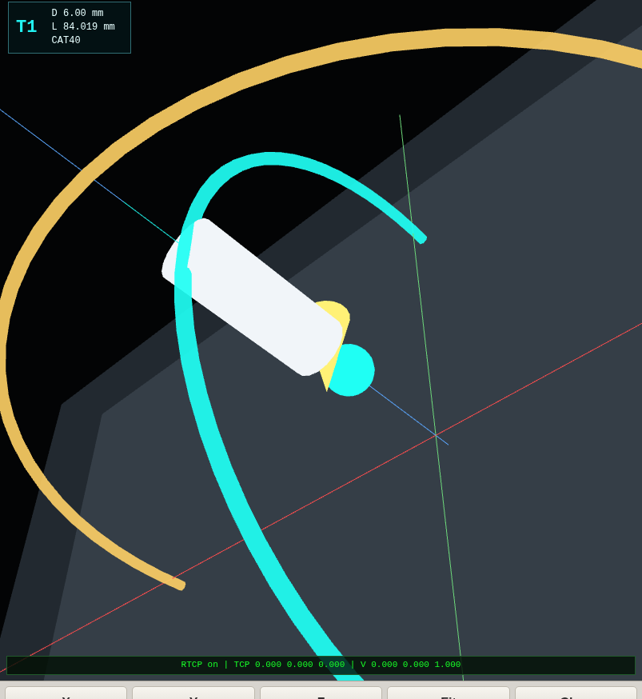
截图文件：/home/meswork/cnc_wams/qa/web-rtcp-5axis-site-test/screenshots/toolpath-preview-cases/01-home-toolpath.png

02-operator-demo-toolpath - PASS
本地矩形 G-code：验证 LinuxCNC interpreter canonical motion、rapid/feed 区分、执行轨迹和 TCP 标记
项目 | 内容
activeProgram | operator-demo.ngc
programSource | operator-file
programExecutionSourceMode | linuxcnc-interpreter-wasm
runState | idle
rtcpState / kinsType | on / tcp-xyzac
motion/sample index | 0 / 0
runtime feedback | linuxcnc-tp-runtime-sample
path/executed/rapid/feed/arc | 6/1/2/4/0
renderer/model | webgl / webgl-five-axis-reference
pixel stats | averageLuminance=59.4, nonBlackRatio=0.7092

检查项
检查 | 结果 | 证据
canvas ready | PASS | threeReady=true
WebGL renderer | PASS | renderer=webgl
机床参考模型 | PASS | scope=machine-reference-and-toolpath, model=webgl-five-axis-reference
TCP 球标记 | PASS | tcp=sphere, marker=true
刀轴线 | PASS | toolAxisMarker=line
场景对象数量 | PASS | sceneObjects=20
无 G-code 语义生成 | PASS | semanticGuard=ok
刀路预览点 | PASS | pathPoints=6
执行轨迹点 | PASS | executed=1
rapid/feed 区分 | PASS | rapid=2, feed=4
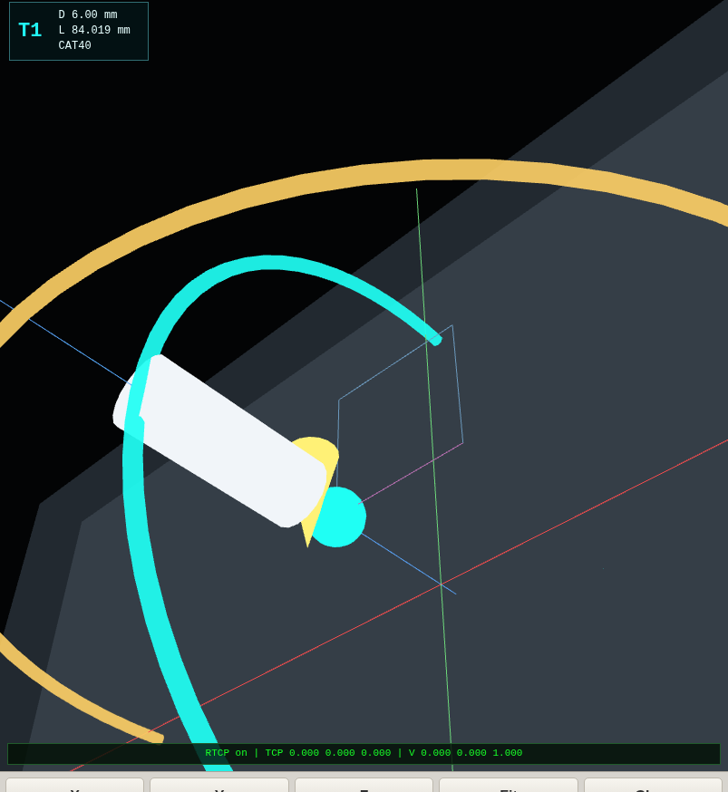
截图文件：/home/meswork/cnc_wams/qa/web-rtcp-5axis-site-test/screenshots/toolpath-preview-cases/02-operator-demo-toolpath.png

03-arc-demo-toolpath - PASS
圆弧 G-code：验证 ARC_FEED 进入弧线轨迹图层并保留执行轨迹
项目 | 内容
activeProgram | operator-arc-demo.ngc
programSource | operator-file
programExecutionSourceMode | linuxcnc-interpreter-wasm
runState | idle
rtcpState / kinsType | on / tcp-xyzac
motion/sample index | 0 / 0
runtime feedback | linuxcnc-tp-runtime-sample
path/executed/rapid/feed/arc | 2/1/1/0/1
renderer/model | webgl / webgl-five-axis-reference
pixel stats | averageLuminance=65.26, nonBlackRatio=0.7885

检查项
检查 | 结果 | 证据
canvas ready | PASS | threeReady=true
WebGL renderer | PASS | renderer=webgl
机床参考模型 | PASS | scope=machine-reference-and-toolpath, model=webgl-five-axis-reference
TCP 球标记 | PASS | tcp=sphere, marker=true
刀轴线 | PASS | toolAxisMarker=line
场景对象数量 | PASS | sceneObjects=20
无 G-code 语义生成 | PASS | semanticGuard=ok
刀路预览点 | PASS | pathPoints=2
执行轨迹点 | PASS | executed=1
圆弧轨迹点 | PASS | arc=1
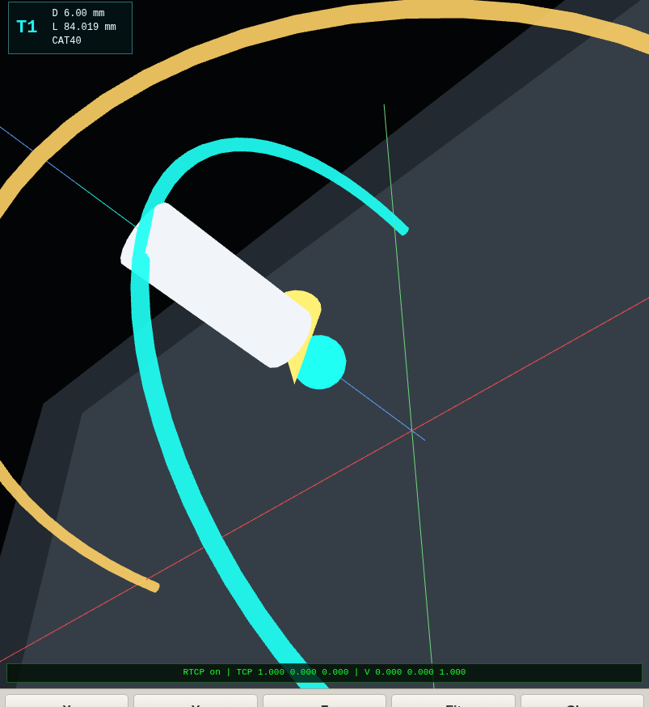
截图文件：/home/meswork/cnc_wams/qa/web-rtcp-5axis-site-test/screenshots/toolpath-preview-cases/03-arc-demo-toolpath.png

04-clear-preview-reference - PASS
清空刀路后：路径点为 0，但机床参考模型、TCP 球和刀轴线仍应可见
项目 | 内容
activeProgram | operator-arc-demo.ngc
programSource | operator-file
programExecutionSourceMode | linuxcnc-interpreter-wasm
runState | idle
rtcpState / kinsType | on / tcp-xyzac
motion/sample index | 0 / 0
runtime feedback | linuxcnc-tp-runtime-sample
path/executed/rapid/feed/arc | 0/0/0/0/0
renderer/model | webgl / webgl-five-axis-reference
pixel stats | averageLuminance=64.72, nonBlackRatio=0.7874

检查项
检查 | 结果 | 证据
canvas ready | PASS | threeReady=true
WebGL renderer | PASS | renderer=webgl
机床参考模型 | PASS | scope=machine-reference-and-toolpath, model=webgl-five-axis-reference
TCP 球标记 | PASS | tcp=sphere, marker=true
刀轴线 | PASS | toolAxisMarker=line
场景对象数量 | PASS | sceneObjects=20
无 G-code 语义生成 | PASS | semanticGuard=ok
路径点期望 | PASS | pathPoints=0, expected=0
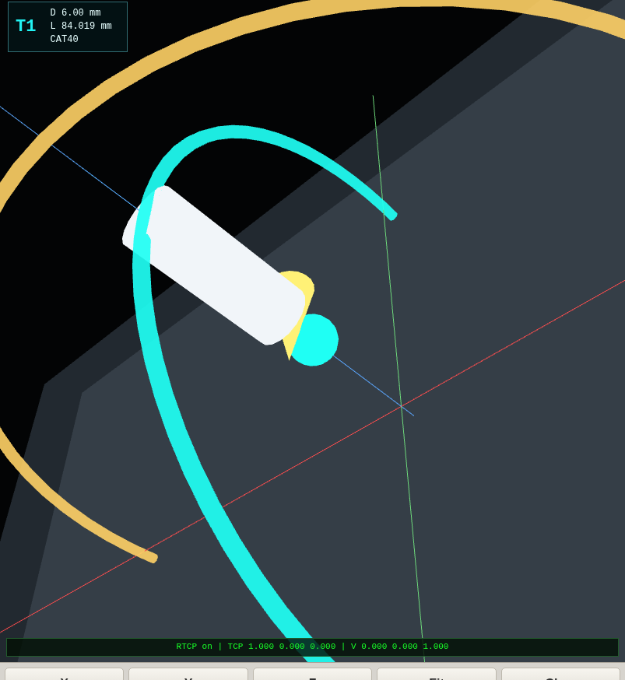
截图文件：/home/meswork/cnc_wams/qa/web-rtcp-5axis-site-test/screenshots/toolpath-preview-cases/04-clear-preview-reference.png

05-vendored-impeller-toolpath - PASS
LinuxCNC vendored 五轴 impeller 程序：验证长路径、switchkins/RTCP 状态、rapid/feed 图层和 TCP 执行轨迹
项目 | 内容
activeProgram | configs/sim/axis/vismach/5axis/table-rotary-tilting/demos/impeller-7bl-xyzac.ngc
programSource | linuxcnc-vendored-5axis-gcode
programExecutionSourceMode | linuxcnc-interpreter-wasm
runState | idle
rtcpState / kinsType | on / tcp-xyzac
motion/sample index | 0 / 0
runtime feedback | linuxcnc-tp-runtime-sample
path/executed/rapid/feed/arc | 1498/1/186/1436/0
renderer/model | webgl / webgl-five-axis-reference
pixel stats | averageLuminance=35.56, nonBlackRatio=0.4577

检查项
检查 | 结果 | 证据
canvas ready | PASS | threeReady=true
WebGL renderer | PASS | renderer=webgl
机床参考模型 | PASS | scope=machine-reference-and-toolpath, model=webgl-five-axis-reference
TCP 球标记 | PASS | tcp=sphere, marker=true
刀轴线 | PASS | toolAxisMarker=line
场景对象数量 | PASS | sceneObjects=20
无 G-code 语义生成 | PASS | semanticGuard=ok
刀路预览点 | PASS | pathPoints=1498
执行轨迹点 | PASS | executed=1
rapid/feed 区分 | PASS | rapid=186, feed=1436
RTCP 状态 | PASS | rtcp=on
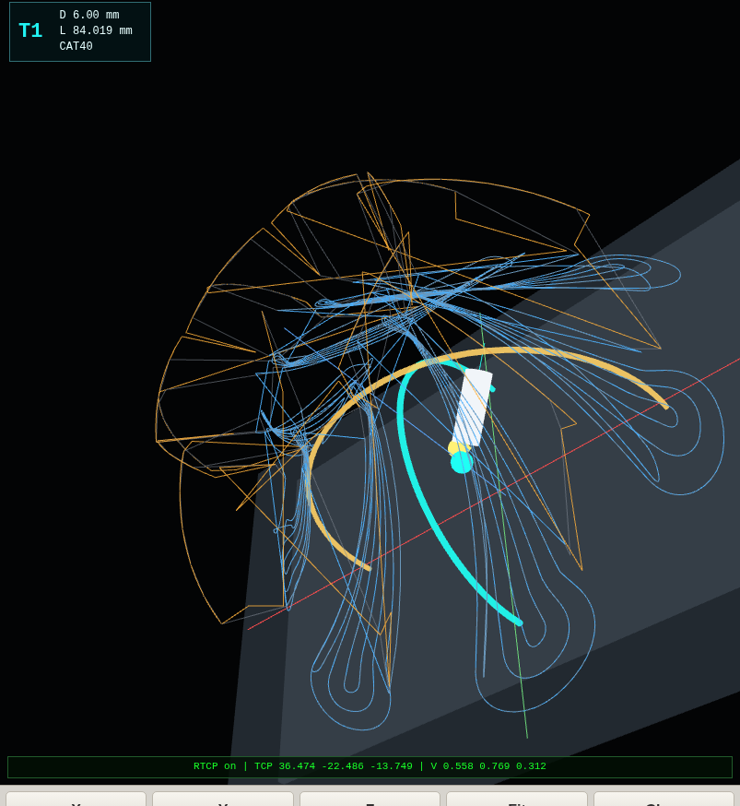
截图文件：/home/meswork/cnc_wams/qa/web-rtcp-5axis-site-test/screenshots/toolpath-preview-cases/05-vendored-impeller-toolpath.png

06-running-rtcp-toolpath - PASS
G-code 运行态：验证 task/HAL runtime feedback 驱动执行轨迹、当前段高亮、TCP 球和刀轴线跟随
项目 | 内容
activeProgram | configs/sim/axis/vismach/5axis/table-rotary-tilting/demos/impeller-7bl-xyzac.ngc
programSource | linuxcnc-vendored-5axis-gcode
programExecutionSourceMode | linuxcnc-interpreter-wasm
runState | running
rtcpState / kinsType | on / tcp-xyzac
motion/sample index | 0 / 0
runtime feedback | linuxcnc-task-motion-hal-wasm
path/executed/rapid/feed/arc | 1498/1/186/1436/0
renderer/model | webgl / webgl-five-axis-reference
pixel stats | averageLuminance=36.05, nonBlackRatio=0.4607

检查项
检查 | 结果 | 证据
canvas ready | PASS | threeReady=true
WebGL renderer | PASS | renderer=webgl
机床参考模型 | PASS | scope=machine-reference-and-toolpath, model=webgl-five-axis-reference
TCP 球标记 | PASS | tcp=sphere, marker=true
刀轴线 | PASS | toolAxisMarker=line
场景对象数量 | PASS | sceneObjects=20
无 G-code 语义生成 | PASS | semanticGuard=ok
刀路预览点 | PASS | pathPoints=1498
执行轨迹点 | PASS | executed=1
rapid/feed 区分 | PASS | rapid=186, feed=1436
RTCP 状态 | PASS | rtcp=on
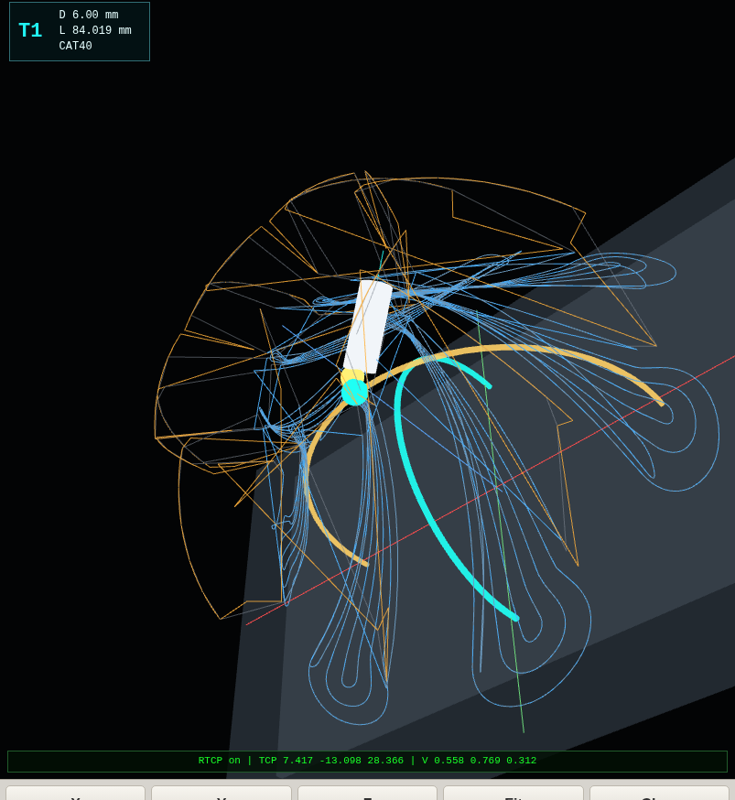
截图文件：/home/meswork/cnc_wams/qa/web-rtcp-5axis-site-test/screenshots/toolpath-preview-cases/06-running-rtcp-toolpath.png

6. 原始证据
项目 | 内容
原始 JSON | /home/meswork/cnc_wams/qa/web-rtcp-5axis-site-test/output/toolpath-preview-cases.json
截图数量 | 6
Console error | 2
Chrome | /usr/bin/google-chrome
Word 报告 | /home/meswork/cnc_wams/qa/web-rtcp-5axis-site-test/output/web-rtcp-5axis-toolpath-preview-report-2026-06-22.docx
项目路径 | /home/meswork/cnc_wams/web-rtcp-5axis-sim-plan/app/index.html

7. Console 记录
Failed to load resource: the server responded with a status of 404 (Not Found)
Failed to load resource: the server responded with a status of 404 (Not Found)

