test_linuxcnc_source RUN 功能测试报告
测试对象：http://127.0.0.1:40261/web-rtcp-5axis-sim-plan/app/index.html
生成时间：2026-06-23 07:39:18 UTC

1. 测试结论
本次使用 working_run/test_linuxcnc_source 中的 INI 与 G-code 文件执行 RUN 测试，结果：PASS。
检查项 | 结果 | 证据
test_linuxcnc_source INI used | PASS | configs/sim/axis/vismach/5axis/table-rotary-tilting/xyzac-trt.ini
test_linuxcnc_source G-code hash matches loaded source | PASS | e90f0b4b6c43809da94a8170ee1029b5afc3e1bbe9bf2ae66298a8baefad013c
刀具路径预览点可见 | PASS | pathPoints=4492
刀具路径使用完整 canonical motion 点 | PASS | threePathPoints=4492, motionEventCount=4492
TCP/刀轴线可见 | PASS | tcp=sphere, axis=line
RUN 采样数量 | PASS | samples=6
每行执行高亮同步 | PASS | 9/9, 10/10, 11/11, 12/12, 12/12, 13/13
程序列表显示每行执行过程 | PASS | 9:running:true, 10:running:true, 11:running:true, 12:running:true, 12:running:true, 13:running:true
执行轨迹可见 | PASS | 1/ok, 1/ok, 1/ok, 1/ok, 1/ok, 1/ok
实时轴值来自 task/HAL feedback | PASS | linuxcnc-task-motion-hal-wasm/true, linuxcnc-task-motion-hal-wasm/true, linuxcnc-task-motion-hal-wasm/true, linuxcnc-task-motion-hal-wasm/true, linuxcnc-task-motion-hal-wasm/true, linuxcnc-task-motion-hal-wasm/true
RUN feed 不是固定 3600 mm/min | PASS | 200ms=2100, 500ms=635.748, 1000ms=283.9176, 2000ms=59.12256, 5000ms=59.12256, 17000ms=58.19616
RUN feed 随实际 G-code F/G93 段变化 | PASS | 2100, 635.748, 283.918, 59.123, 58.196
RUN 使用 G93 inverse-time feed | PASS | 200ms F4500000 inverse-time 0.4571722972663097s, 500ms F318 inverse-time 0.18867924528301888s, 1000ms F159 inverse-time 0.37735849056603776s, 2000ms F159 inverse-time 0.37735849056603776s, 5000ms F159 inverse-time 0.37735849056603776s, 17000ms F159 inverse-time 0.37735849056603776s
task/HAL cycle 推进 | PASS | 35/350, 60/600, 85/850, 110/1100, 135/1350, 155/1550
STOP 后 loop 停止 | PASS | active=false, stopReason=stopped

2. 测试源文件
项目 | 内容
INI | /home/meswork/cnc_wams/web-rtcp-5axis-sim-plan/working_run/test_linuxcnc_source/xyzac-trt.ini
INI SHA-256 | 4b7fa6cb8d3e7031e769b3e0c779b586b67cfd45d715985f40d4ec23c662dc97
G-code | /home/meswork/cnc_wams/web-rtcp-5axis-sim-plan/working_run/test_linuxcnc_source/impeller-7bl-xyzac.ngc
G-code SHA-256 | e90f0b4b6c43809da94a8170ee1029b5afc3e1bbe9bf2ae66298a8baefad013c
G-code 行数/字节 | 4511 / 294411

3. 测试过程

01-initial-ui - 初始界面
确认浏览器应用、五轴预览区、G-code 区和 DRO 面板已渲染。
项目 | 内容
activeProgram | configs/sim/axis/vismach/5axis/table-rotary-tilting/demos/boat-xyzac.ngc
runState / activeLine | idle / 1
program source | linuxcnc-vendored-5axis-gcode / linuxcnc-task-motion-hal-wasm
selected G-code | configs/sim/axis/vismach/5axis/table-rotary-tilting/demos/boat-xyzac.ngc
task/HAL program | /work/sim/axis/vismach/5axis/table-rotary-tilting/xyzac-trt/demos/boat-xyzac.ngc
DRO XYZAC | X=0.000 Y=0.000 Z=0.000 A=0.000 B=0.000 C=0.000
axisPose XYZAC | X=0.000 Y=0.000 Z=0.000 A=0.000 B=0.000 C=0.000
path/executed | 2 / 1
RTCP / kins | on / tcp-xyzac
pixel | luma=128.52, nonBlack=0.7817
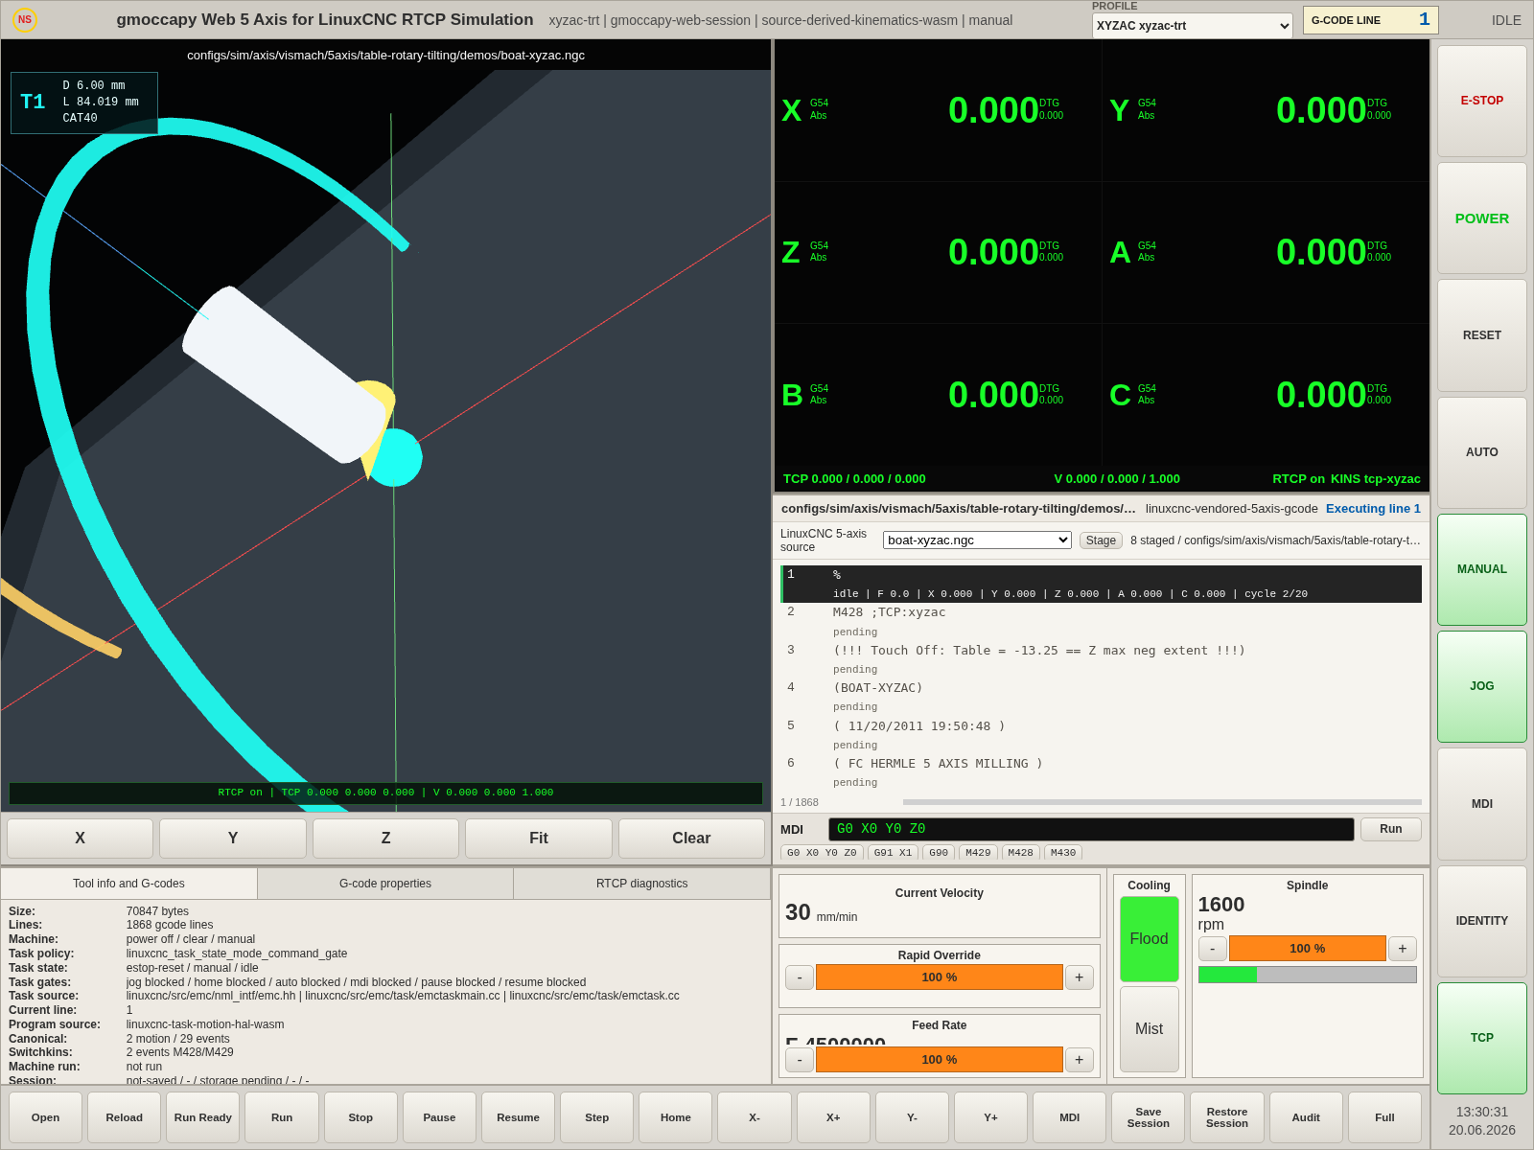
截图文件：/home/meswork/cnc_wams/qa/web-rtcp-5axis-site-test/screenshots/test-linuxcnc-source-run/01-initial-ui.png

02-stage-test-ini - Stage test_linuxcnc_source INI
使用 working_run/test_linuxcnc_source/xyzac-trt.ini 重新 staging machine files。
项目 | 内容
activeProgram | configs/sim/axis/vismach/5axis/table-rotary-tilting/demos/boat-xyzac.ngc
runState / activeLine | idle / 1
program source | linuxcnc-vendored-5axis-gcode / linuxcnc-task-motion-hal-wasm
selected G-code | -
task/HAL program | /work/sim/axis/vismach/5axis/table-rotary-tilting/xyzac-trt/demos/xyzac_switchkins.ngc
DRO XYZAC | X=0.000 Y=0.000 Z=0.000 A=0.000 B=0.000 C=0.000
axisPose XYZAC | X=0.000 Y=0.000 Z=0.000 A=0.000 B=0.000 C=0.000
path/executed | 2 / 1
RTCP / kins | on / tcp-xyzac
pixel | luma=128.59, nonBlack=0.7817
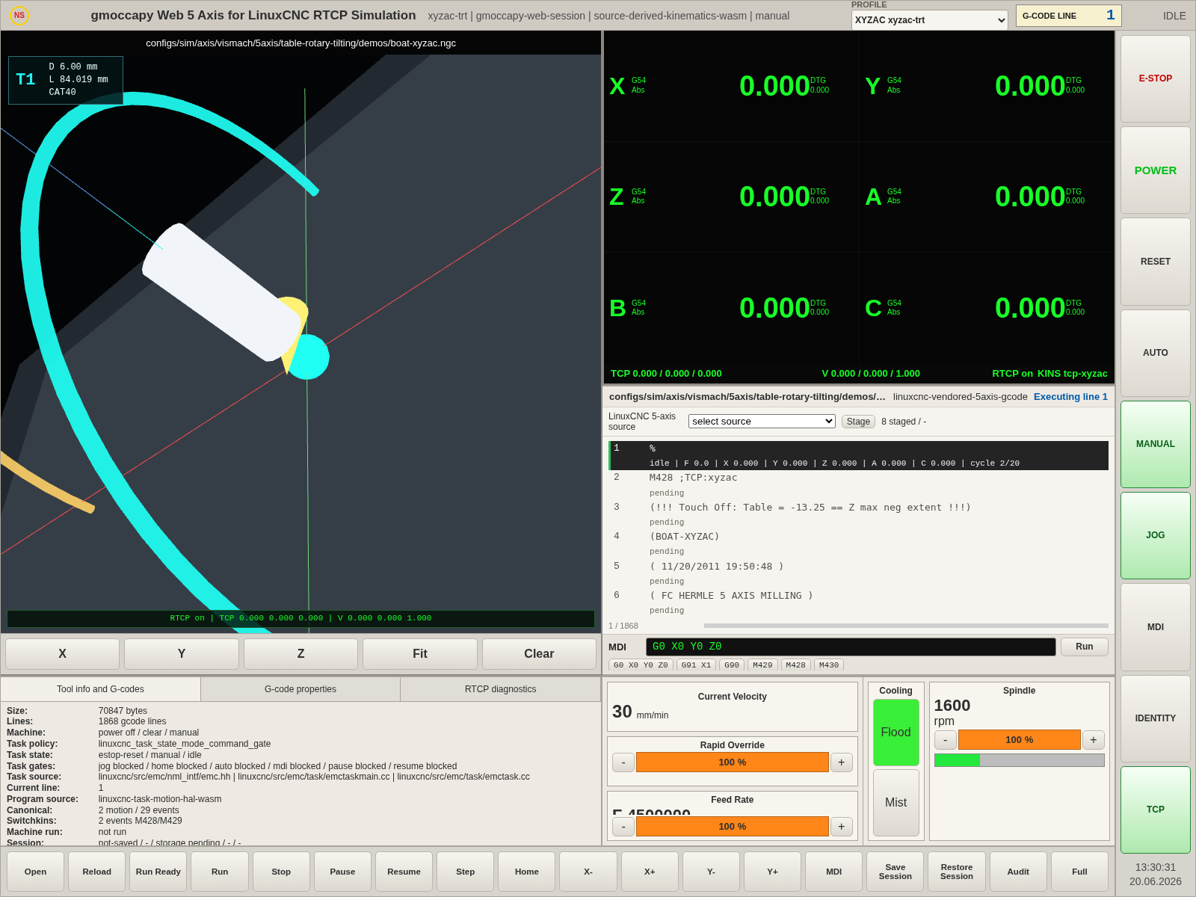
截图文件：/home/meswork/cnc_wams/qa/web-rtcp-5axis-site-test/screenshots/test-linuxcnc-source-run/02-stage-test-ini.png

03-toolpath-preview - 刀具路径预览
加载 test_linuxcnc_source/impeller-7bl-xyzac.ngc 对应程序，确认 canonical motion 预览路径、TCP 球和刀轴线可见。
项目 | 内容
activeProgram | configs/sim/axis/vismach/5axis/table-rotary-tilting/demos/impeller-7bl-xyzac.ngc
runState / activeLine | idle / 1
program source | linuxcnc-vendored-5axis-gcode / linuxcnc-task-motion-hal-wasm
selected G-code | configs/sim/axis/vismach/5axis/table-rotary-tilting/demos/impeller-7bl-xyzac.ngc
task/HAL program | /work/sim/axis/vismach/5axis/table-rotary-tilting/xyzac-trt/demos/impeller-7bl-xyzac.ngc
DRO XYZAC | X=0.000 Y=0.000 Z=0.000 A=0.000 B=0.000 C=0.000
axisPose XYZAC | X=0.000 Y=0.000 Z=0.000 A=0.000 B=0.000 C=0.000
path/executed | 4492 / 1
RTCP / kins | on / tcp-xyzac
pixel | luma=127.63, nonBlack=0.7643
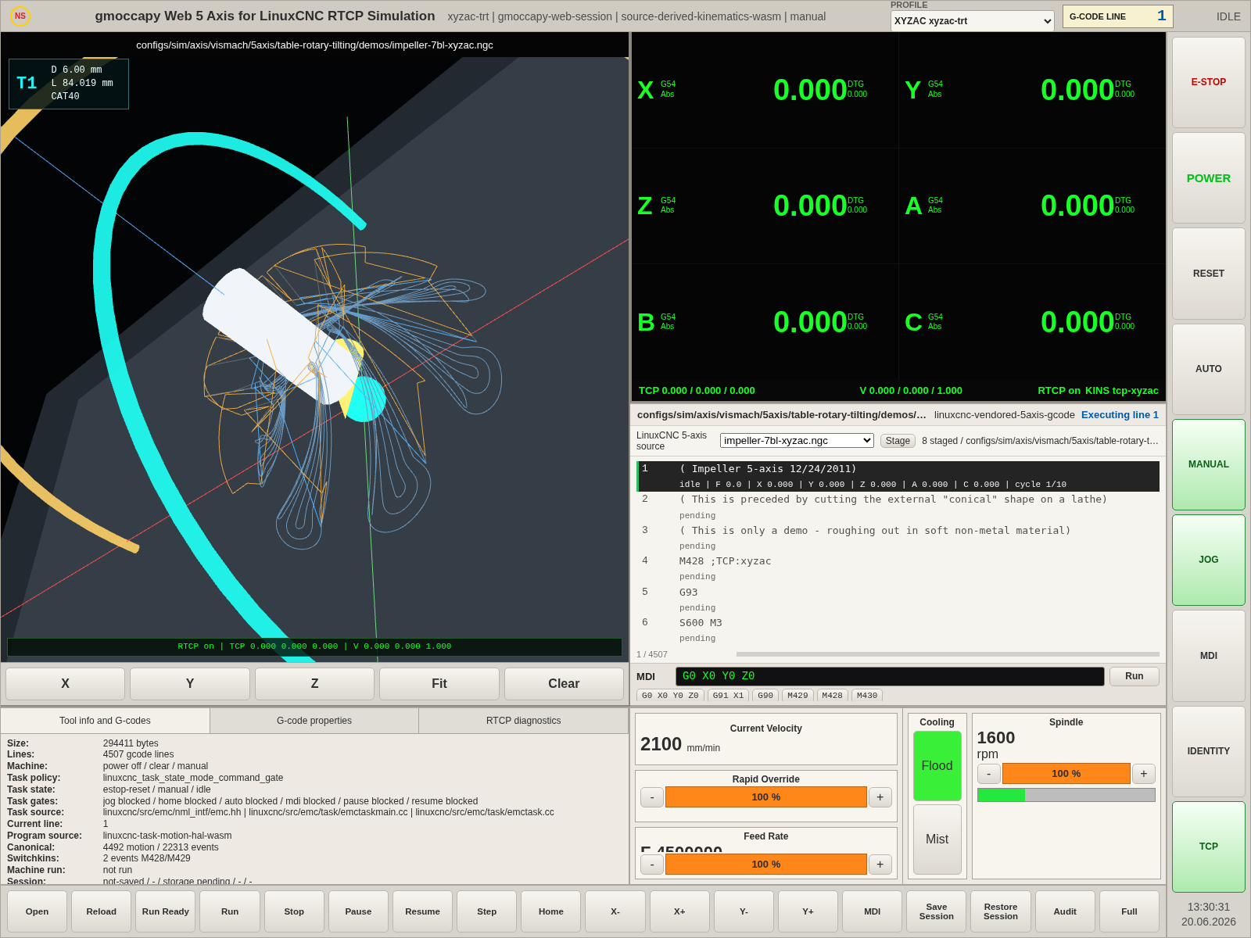
截图文件：/home/meswork/cnc_wams/qa/web-rtcp-5axis-site-test/screenshots/test-linuxcnc-source-run/03-toolpath-preview.png

04-ready-before-run - RUN 前准备
POWER ON、HOME、AUTO、TCP 模式就绪，RUN gate 所需条件已满足。
项目 | 内容
activeProgram | configs/sim/axis/vismach/5axis/table-rotary-tilting/demos/impeller-7bl-xyzac.ngc
runState / activeLine | idle / 1
program source | linuxcnc-vendored-5axis-gcode / linuxcnc-task-motion-hal-wasm
selected G-code | configs/sim/axis/vismach/5axis/table-rotary-tilting/demos/impeller-7bl-xyzac.ngc
task/HAL program | /work/sim/axis/vismach/5axis/table-rotary-tilting/xyzac-trt/demos/impeller-7bl-xyzac.ngc
DRO XYZAC | X=0.000 Y=0.000 Z=0.000 A=0.000 B=0.000 C=0.000
axisPose XYZAC | X=0.000 Y=0.000 Z=0.000 A=0.000 B=0.000 C=0.000
path/executed | 4492 / 1
RTCP / kins | on / tcp-xyzac
pixel | luma=127.67, nonBlack=0.7643
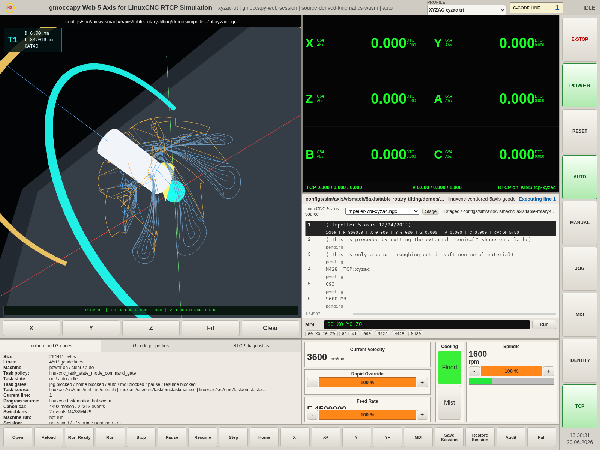
截图文件：/home/meswork/cnc_wams/qa/web-rtcp-5axis-site-test/screenshots/test-linuxcnc-source-run/04-ready-before-run.png

05-run-0200ms - G-code 执行 200ms
采集 G-code 当前高亮行、执行轨迹、实时 DRO/axisPose 和 task/HAL feedback。
项目 | 内容
activeProgram | configs/sim/axis/vismach/5axis/table-rotary-tilting/demos/impeller-7bl-xyzac.ngc
runState / activeLine | running / 9
program source | linuxcnc-vendored-5axis-gcode / linuxcnc-task-motion-hal-wasm
selected G-code | configs/sim/axis/vismach/5axis/table-rotary-tilting/demos/impeller-7bl-xyzac.ngc
task/HAL program | /work/sim/axis/vismach/5axis/table-rotary-tilting/xyzac-trt/demos/impeller-7bl-xyzac.ngc
DRO XYZAC | X=10.484 Y=-17.330 Z=30.081 A=-71.841 B=0.000 C=-35.930
axisPose XYZAC | X=10.484 Y=-17.330 Z=30.081 A=-71.841 B=0.000 C=-35.930
path/executed | 4492 / 1
RTCP / kins | on / tcp-xyzac
pixel | luma=130.81, nonBlack=0.765
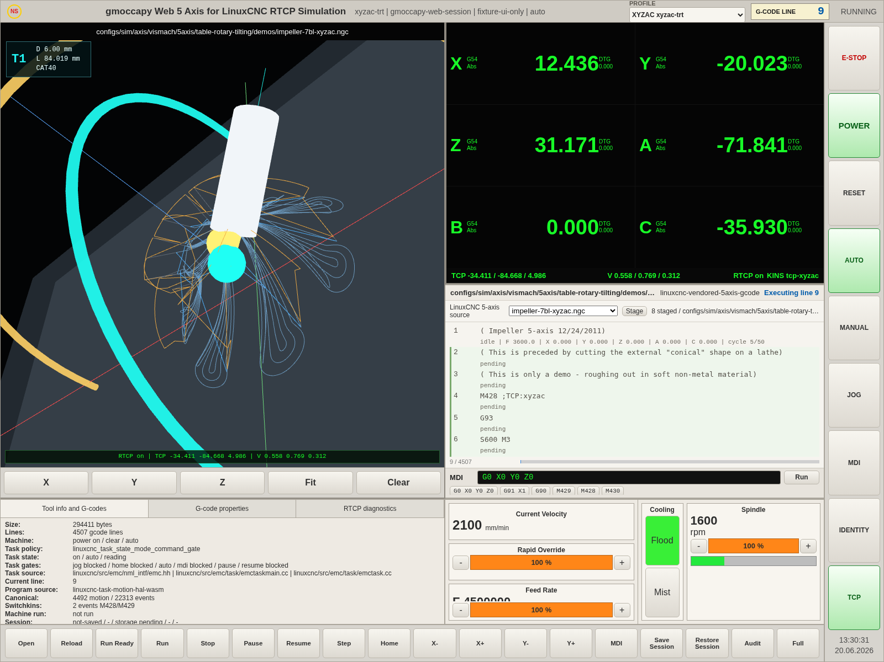
截图文件：/home/meswork/cnc_wams/qa/web-rtcp-5axis-site-test/screenshots/test-linuxcnc-source-run/05-run-0200ms.png

05-run-0500ms - G-code 执行 500ms
采集 G-code 当前高亮行、执行轨迹、实时 DRO/axisPose 和 task/HAL feedback。
项目 | 内容
activeProgram | configs/sim/axis/vismach/5axis/table-rotary-tilting/demos/impeller-7bl-xyzac.ngc
runState / activeLine | running / 10
program source | linuxcnc-vendored-5axis-gcode / linuxcnc-task-motion-hal-wasm
selected G-code | configs/sim/axis/vismach/5axis/table-rotary-tilting/demos/impeller-7bl-xyzac.ngc
task/HAL program | /work/sim/axis/vismach/5axis/table-rotary-tilting/xyzac-trt/demos/impeller-7bl-xyzac.ngc
DRO XYZAC | X=6.868 Y=-12.341 Z=28.059 A=-71.841 B=0.000 C=-35.930
axisPose XYZAC | X=6.868 Y=-12.341 Z=28.059 A=-71.841 B=0.000 C=-35.930
path/executed | 4492 / 1
RTCP / kins | on / tcp-xyzac
pixel | luma=130.59, nonBlack=0.7649
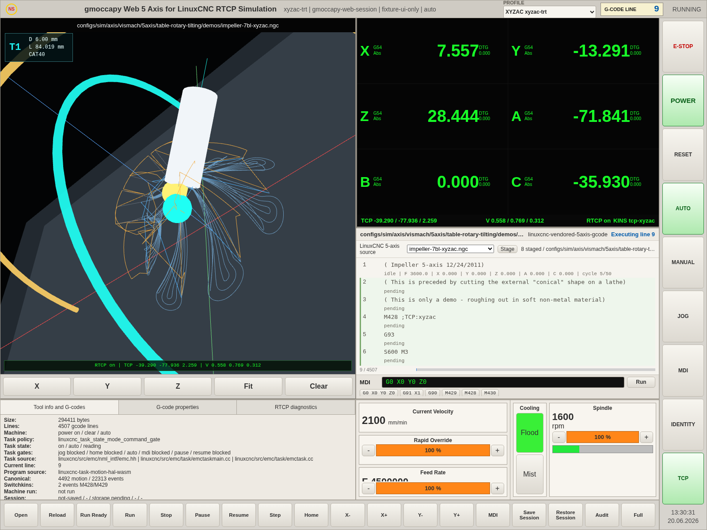
截图文件：/home/meswork/cnc_wams/qa/web-rtcp-5axis-site-test/screenshots/test-linuxcnc-source-run/05-run-0500ms.png

05-run-1000ms - G-code 执行 1000ms
采集 G-code 当前高亮行、执行轨迹、实时 DRO/axisPose 和 task/HAL feedback。
项目 | 内容
activeProgram | configs/sim/axis/vismach/5axis/table-rotary-tilting/demos/impeller-7bl-xyzac.ngc
runState / activeLine | running / 11
program source | linuxcnc-vendored-5axis-gcode / linuxcnc-task-motion-hal-wasm
selected G-code | configs/sim/axis/vismach/5axis/table-rotary-tilting/demos/impeller-7bl-xyzac.ngc
task/HAL program | /work/sim/axis/vismach/5axis/table-rotary-tilting/xyzac-trt/demos/impeller-7bl-xyzac.ngc
DRO XYZAC | X=6.325 Y=-11.911 Z=27.104 A=-71.606 B=0.000 C=-34.700
axisPose XYZAC | X=6.325 Y=-11.911 Z=27.104 A=-71.606 B=0.000 C=-34.700
path/executed | 4492 / 1
RTCP / kins | on / tcp-xyzac
pixel | luma=130.48, nonBlack=0.7649
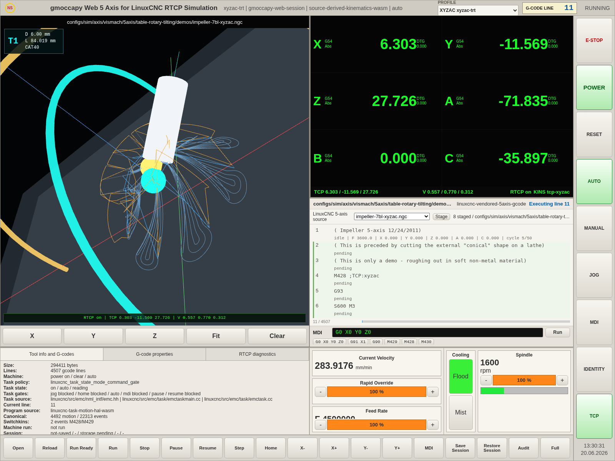
截图文件：/home/meswork/cnc_wams/qa/web-rtcp-5axis-site-test/screenshots/test-linuxcnc-source-run/05-run-1000ms.png

05-run-2000ms - G-code 执行 2000ms
采集 G-code 当前高亮行、执行轨迹、实时 DRO/axisPose 和 task/HAL feedback。
项目 | 内容
activeProgram | configs/sim/axis/vismach/5axis/table-rotary-tilting/demos/impeller-7bl-xyzac.ngc
runState / activeLine | running / 12
program source | linuxcnc-vendored-5axis-gcode / linuxcnc-task-motion-hal-wasm
selected G-code | configs/sim/axis/vismach/5axis/table-rotary-tilting/demos/impeller-7bl-xyzac.ngc
task/HAL program | /work/sim/axis/vismach/5axis/table-rotary-tilting/xyzac-trt/demos/impeller-7bl-xyzac.ngc
DRO XYZAC | X=6.357 Y=-12.431 Z=26.155 A=-71.258 B=0.000 C=-32.875
axisPose XYZAC | X=6.357 Y=-12.431 Z=26.155 A=-71.258 B=0.000 C=-32.875
path/executed | 4492 / 1
RTCP / kins | on / tcp-xyzac
pixel | luma=130.47, nonBlack=0.7649
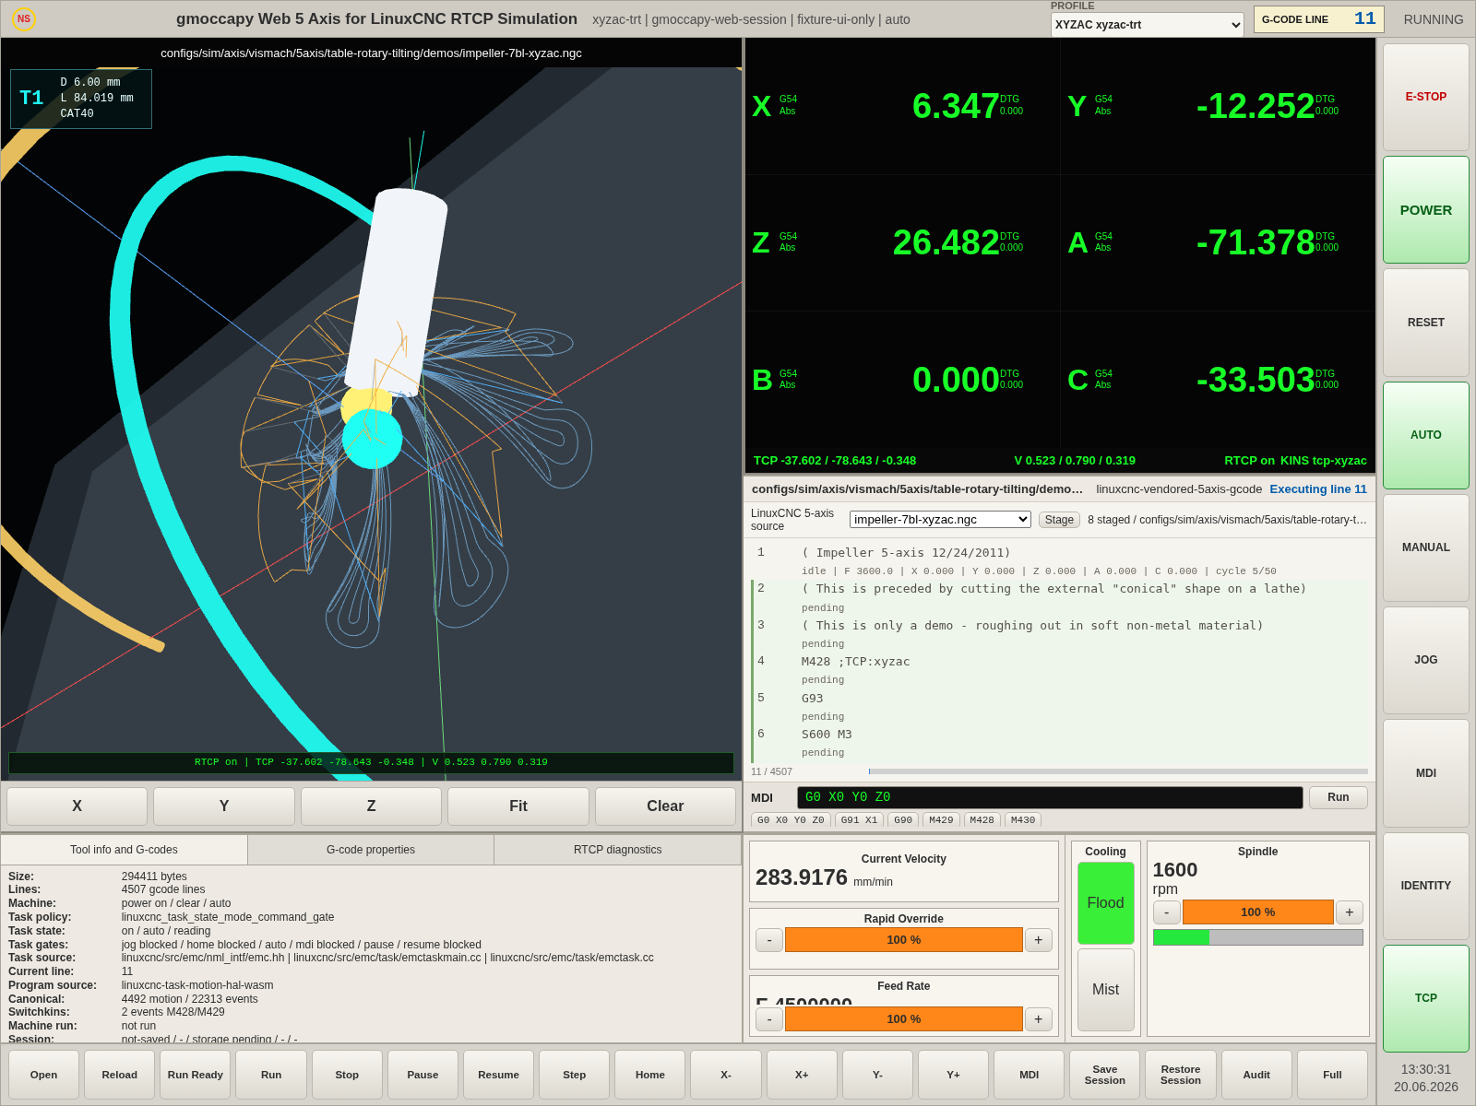
截图文件：/home/meswork/cnc_wams/qa/web-rtcp-5axis-site-test/screenshots/test-linuxcnc-source-run/05-run-2000ms.png

05-run-5000ms - G-code 执行 5000ms
采集 G-code 当前高亮行、执行轨迹、实时 DRO/axisPose 和 task/HAL feedback。
项目 | 内容
activeProgram | configs/sim/axis/vismach/5axis/table-rotary-tilting/demos/impeller-7bl-xyzac.ngc
runState / activeLine | running / 12
program source | linuxcnc-vendored-5axis-gcode / linuxcnc-task-motion-hal-wasm
selected G-code | configs/sim/axis/vismach/5axis/table-rotary-tilting/demos/impeller-7bl-xyzac.ngc
task/HAL program | /work/sim/axis/vismach/5axis/table-rotary-tilting/xyzac-trt/demos/impeller-7bl-xyzac.ngc
DRO XYZAC | X=6.349 Y=-12.557 Z=25.943 A=-71.187 B=0.000 C=-32.468
axisPose XYZAC | X=6.349 Y=-12.557 Z=25.943 A=-71.187 B=0.000 C=-32.468
path/executed | 4492 / 1
RTCP / kins | on / tcp-xyzac
pixel | luma=130.45, nonBlack=0.7648
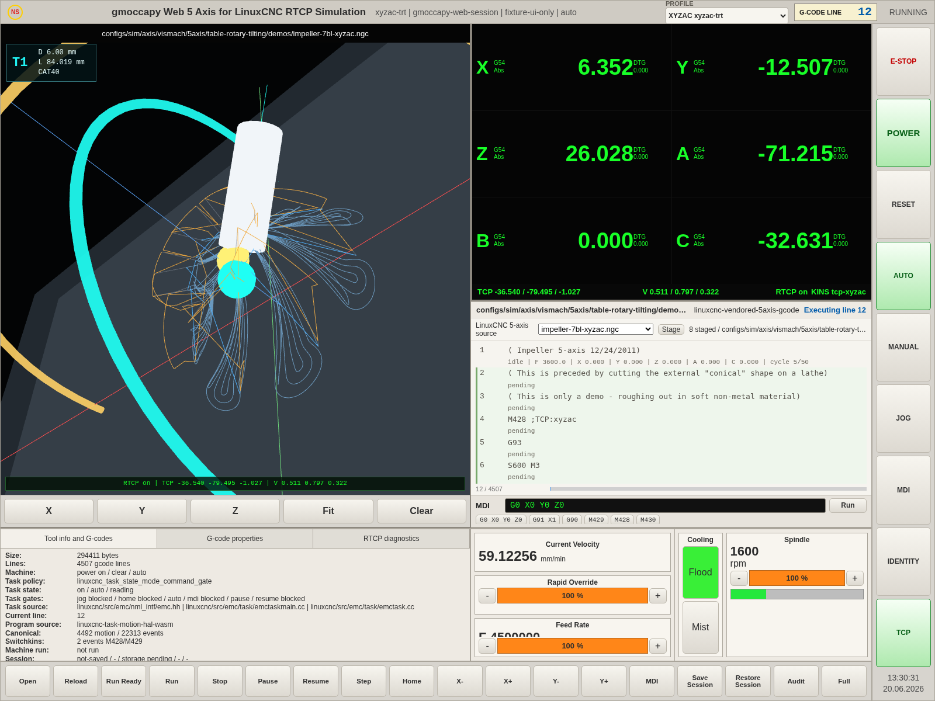
截图文件：/home/meswork/cnc_wams/qa/web-rtcp-5axis-site-test/screenshots/test-linuxcnc-source-run/05-run-5000ms.png

05-run-17000ms - G-code 执行 17000ms
采集 G-code 当前高亮行、执行轨迹、实时 DRO/axisPose 和 task/HAL feedback。
项目 | 内容
activeProgram | configs/sim/axis/vismach/5axis/table-rotary-tilting/demos/impeller-7bl-xyzac.ngc
runState / activeLine | running / 13
program source | linuxcnc-vendored-5axis-gcode / linuxcnc-task-motion-hal-wasm
selected G-code | configs/sim/axis/vismach/5axis/table-rotary-tilting/demos/impeller-7bl-xyzac.ngc
task/HAL program | /work/sim/axis/vismach/5axis/table-rotary-tilting/xyzac-trt/demos/impeller-7bl-xyzac.ngc
DRO XYZAC | X=6.336 Y=-12.659 Z=25.777 A=-71.141 B=0.000 C=-32.149
axisPose XYZAC | X=6.336 Y=-12.659 Z=25.777 A=-71.141 B=0.000 C=-32.149
path/executed | 4492 / 1
RTCP / kins | on / tcp-xyzac
pixel | luma=130.44, nonBlack=0.765
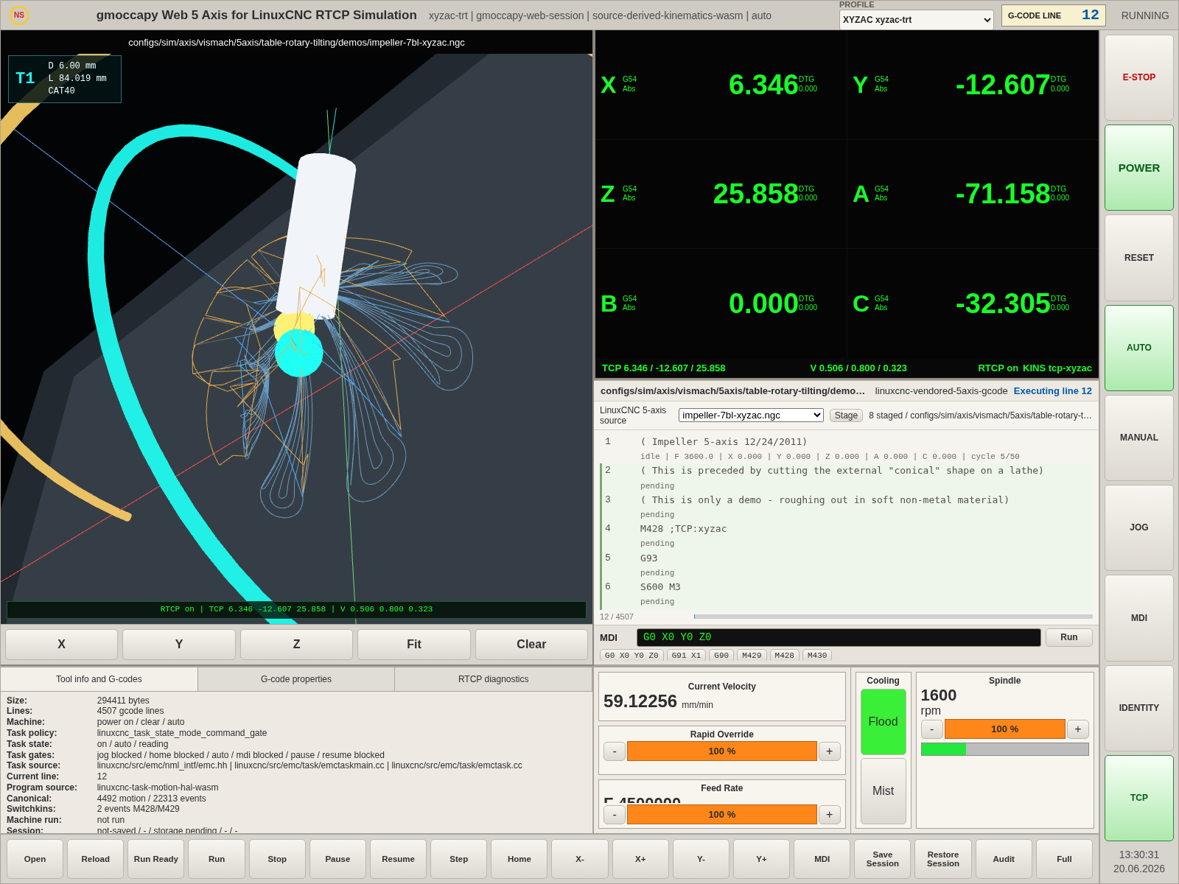
截图文件：/home/meswork/cnc_wams/qa/web-rtcp-5axis-site-test/screenshots/test-linuxcnc-source-run/05-run-17000ms.png

06-stop-after-run - STOP 后状态
停止 RUN，确认 status loop 停止且执行证据已保留。
项目 | 内容
activeProgram | configs/sim/axis/vismach/5axis/table-rotary-tilting/demos/impeller-7bl-xyzac.ngc
runState / activeLine | stopped / 13
program source | linuxcnc-vendored-5axis-gcode / linuxcnc-task-motion-hal-wasm
selected G-code | configs/sim/axis/vismach/5axis/table-rotary-tilting/demos/impeller-7bl-xyzac.ngc
task/HAL program | /work/sim/axis/vismach/5axis/table-rotary-tilting/xyzac-trt/demos/impeller-7bl-xyzac.ngc
DRO XYZAC | X=6.331 Y=-12.685 Z=25.737 A=-71.132 B=0.000 C=-32.071
axisPose XYZAC | X=6.331 Y=-12.685 Z=25.737 A=-71.132 B=0.000 C=-32.071
path/executed | 4492 / 1
RTCP / kins | on / tcp-xyzac
pixel | luma=130.4, nonBlack=0.7647
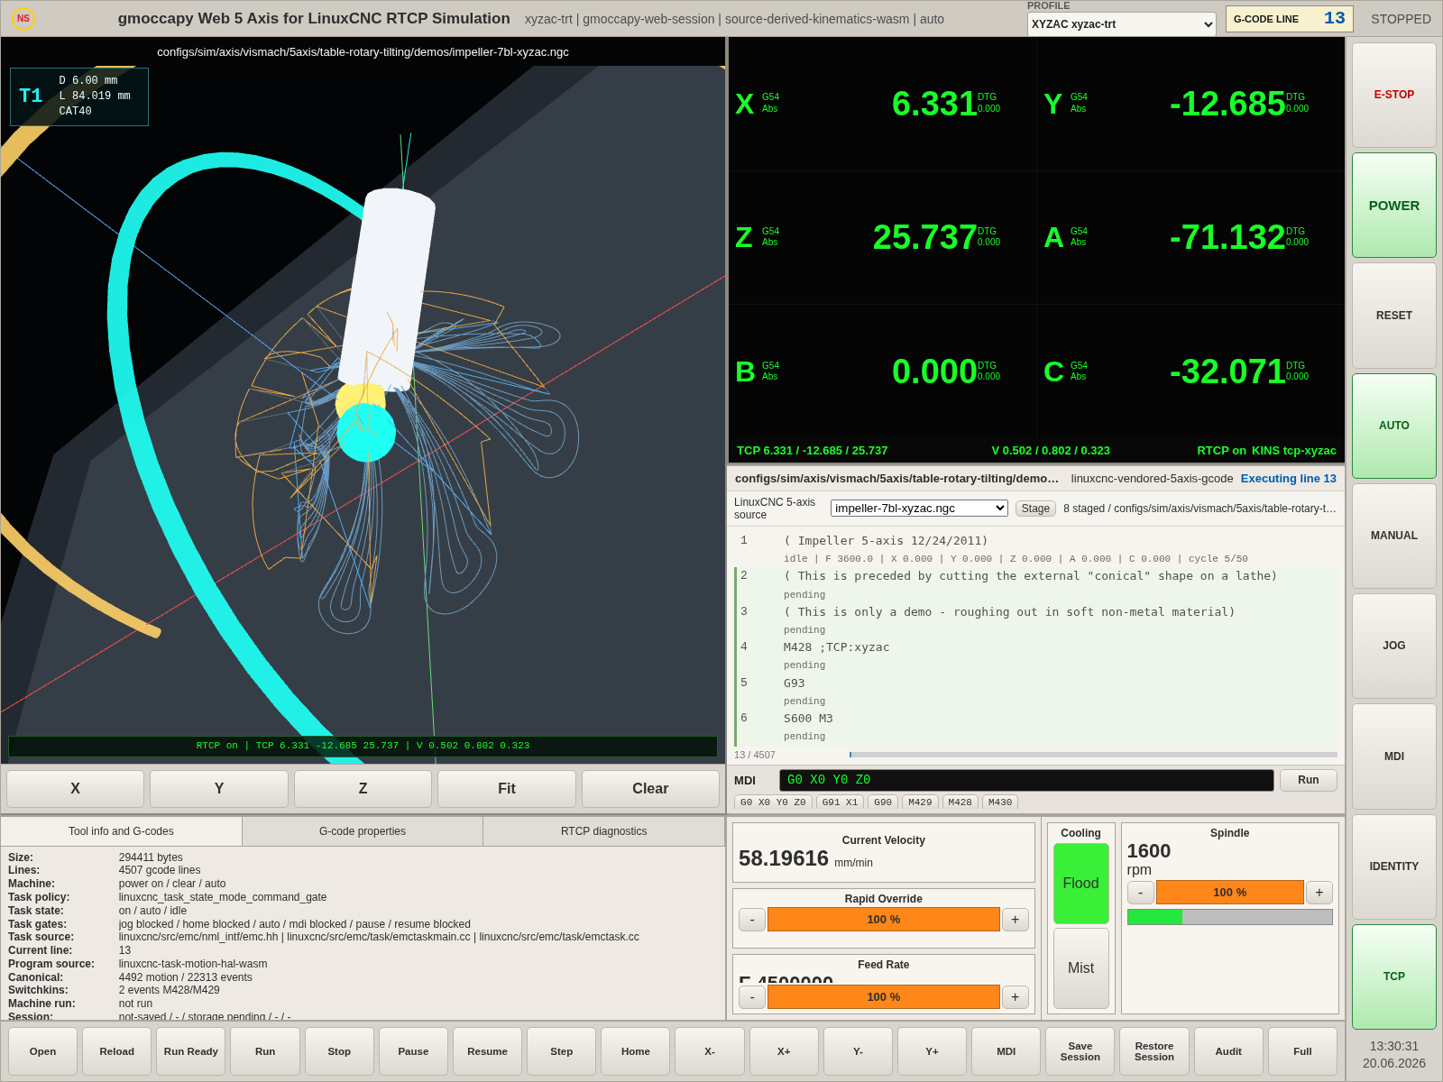
截图文件：/home/meswork/cnc_wams/qa/web-rtcp-5axis-site-test/screenshots/test-linuxcnc-source-run/06-stop-after-run.png

4. RUN 采样明细
时间 | 行号 | 状态 | DRO XYZAC | 速度/feed | 轨迹点 | 反馈
200ms | 9 / UI 9 | running | X=10.484 Y=-17.330 Z=30.081 A=-71.841 B=0.000 C=-35.930 | 2100 mm/min  F4500000 inverse-time | 1 | linuxcnc-task-motion-hal-wasm  cycle=35/350
500ms | 10 / UI 10 | running | X=6.868 Y=-12.341 Z=28.059 A=-71.841 B=0.000 C=-35.930 | 635.748 mm/min  F318 inverse-time | 1 | linuxcnc-task-motion-hal-wasm  cycle=60/600
1000ms | 11 / UI 11 | running | X=6.325 Y=-11.911 Z=27.104 A=-71.606 B=0.000 C=-34.700 | 283.9176 mm/min  F159 inverse-time | 1 | linuxcnc-task-motion-hal-wasm  cycle=85/850
2000ms | 12 / UI 12 | running | X=6.357 Y=-12.431 Z=26.155 A=-71.258 B=0.000 C=-32.875 | 59.12256 mm/min  F159 inverse-time | 1 | linuxcnc-task-motion-hal-wasm  cycle=110/1100
5000ms | 12 / UI 12 | running | X=6.349 Y=-12.557 Z=25.943 A=-71.187 B=0.000 C=-32.468 | 59.12256 mm/min  F159 inverse-time | 1 | linuxcnc-task-motion-hal-wasm  cycle=135/1350
17000ms | 13 / UI 13 | running | X=6.336 Y=-12.659 Z=25.777 A=-71.141 B=0.000 C=-32.149 | 58.19616 mm/min  F159 inverse-time | 1 | linuxcnc-task-motion-hal-wasm  cycle=155/1550

5. 原始证据
项目 | 内容
JSON | /home/meswork/cnc_wams/qa/web-rtcp-5axis-site-test/output/test-linuxcnc-source-run-report.json
截图目录 | /home/meswork/cnc_wams/qa/web-rtcp-5axis-site-test/screenshots/test-linuxcnc-source-run
Word | /home/meswork/cnc_wams/qa/web-rtcp-5axis-site-test/output/test-linuxcnc-source-run-report-2026-06-23.docx
Console error | 2
Chrome | /usr/bin/google-chrome

6. Console Error
Failed to load resource: the server responded with a status of 404 (Not Found)
Failed to load resource: the server responded with a status of 404 (Not Found)

